

**CAPSTONE PROJECT 1**

**PROJECT PLAN DOCUMENT**

**English for you**

**Version: v1.0**

**Project Team: fantastic 4**

**Date Create: 22 – Sep - 2018**

|  |  |  |  |  |  |
| --- | --- | --- | --- | --- | --- |
|  | **PROJECT INFORMATION** | | | | |
| **Project Acronym** |  | | | | |
| **Project Title** | English For You | | | | |
| **Start Date** | 15 – Aug – 2018 | **End Date** | | 5 – Dec – 2018 | |
| **Lead Institution** | International School, Duy Tan University | | | | |
| **Project Mentor** | MSc. Truong Tien Vu | | | | |
| **Product Owner & Contact Detail** | Mr. Vu Truong Tien  Email: vudalat@yahoo.com  Tel: 0914083188 | | | | |
| **Partner Organization** |  | | | | |
| **Scrum Master** | Tran Nguyen Huu Nghia | | trannguyenhuunghia97@gmail.com | | 0934848229 |
| **Team Members** | Truong, Do Van | | [Truongdtct1230@gmail.com](mailto:Truongdtct1230@gmail.com) | | 01674275453 |
| Oanh, Doan Nu Thuc | | [Doannuthucoanh0410@gmail.com](mailto:Doannuthucoanh0410@gmail.com) | | 01674552075 |
| Truc, Dinh Tran Anh | | [Anhtruc2091997@gmail.com](mailto:Anhtruc2091997@gmail.com) | | 0947360347 |

|  |  |  |  |
| --- | --- | --- | --- |
|  | **DOCUMENT NAME** | | |
|  |  | | |
| **Document Title** | Project plan | | |
| **Author(s)** | Fantastic 4 Team | | |
| **Role** |  | | |
| **Date** | 23 – Sep– 2018 | **File name:** | [E4U]Project Plan v1.0 |
| **URL** |  | | |
| **Access** |  | | |

### REVISION HISTORY

|  |  |  |  |
| --- | --- | --- | --- |
| **Version** | **Person(s)** | **Date** | **Description** |
| **1.0** | Fantastic 4 Team | 23 – Sep - 2018 | Create Project plan document |
|  |  |  |  |

|  |  |  |  |
| --- | --- | --- | --- |
| **Document Approval**  The following signatures are required for approval of this document | | | |
| **Mentor** | Truong Tien Vu | **Signature:** |  |
| **Date:** |  |
|  | **Signature:** |  |
| **Date:** |  |
| **Scrum Master** | Tran Nguyen Huu Nghia | **Signature:** |  |
| **Date:** |  |
| **Team Member(s)** | Do Van Truong | **Signature:** |  |
| **Date:** |  |
| Doan Nu Thuc Oanh | **Signature:** |  |
| **Date:** |  |
| Dinh Tran Anh Truc | **Signature:** |  |
| **Date:** |  |

REVISION HISTORY 3

**1.** **Introduction:** 5

1.1. Purpose: 5

1.2. Scope: 6

1.3. Project Overview: 6

**2.** **Team Organization:** 6

2.1. Scrum Team Information: 6

2.2. Role and Responsibility: 6

2.3. Communication Methodology: 8

2.4. Communication and Report: 8

**3.** **Assumptions and Constrains** 9

**3.1.** **Assumptions** 9

3.2. Constrains 9

**4.** **Schedule and Cost:** 10

4.1. Detailed Schedule: 10

4.2. Cost: 12

**5.** **Development Process:** 12

**6.** **Project’s Risk:** 14

**7.** **Deliverables:** 16

1. **Introduction:**
   1. **Purpose:**

* This document provides a summary of the project's objectives, division of work, the major milestones, required resources, time and overall schedule and budget allocation used and based on the document proposal to build an expense management application on time, at the request and plan.
* The following people use the Project Plan:
  + The project manager uses it to plan the project schedule and resource needs, and to track progress against the schedule.
  + Project team members use it to understand what they need to do, when they need to do it, and what other activities they are dependent upon.
* his document defines the approach to be used by the Project team to deliver the intended project management scope of the project.
* This document contains the details required to execute the project successfully. Once project execution begins, this plan will be reviewed, baseline, and updated on the regular basis.
  1. **Scope:**
* This Project Plan describes the overall plan to be used by the ***English For You***, including deployment of the product. The details of the individual iterations will be described in the Release Plans.
* This document will schedule the project plan into Work Breakdown Structure to let Product Owner easily review and manage Scrum team working and delivery on time.
* The plans as outlined in this document are based upon the product requirements as defined in the User Stories document.
  1. **Project Overview:**

Developed Eng4you website is a website that help user learning English through game. Two people in one team co-operate with each other to explain words, User can listen music and write sentences in that song, and user can chat with foreign to raise their English skill

***Reference to Proposal.docx***

1. **Team Organization:**
   1. **Scrum Team Information:**

***Table 1: Scrum Team Organization.***

|  |  |  |  |
| --- | --- | --- | --- |
| **Full Name** | **Phone** | **Email** | **Position** |
| Tran Nguye Huu Nghia | 0934848229 | trannguyenhuunghia97@gmail.com | Scrum Master |
| Do Van Truong | 01674275453 | [Truongdtct1230@gmail.com](mailto:Truongdtct1230@gmail.com) | Member |
| Doan Nu Thuc Oanh | 01674552075 | [Doannuthucoanh0410@gmail.com](mailto:Doannuthucoanh0410@gmail.com) | Member |
| Dinh Tran Anh Truc | 0947360347 | [Anhtruc2091997@gmail.com](mailto:Anhtruc2091997@gmail.com) | Member |

* 1. **Role and Responsibility:**

***Table 2: Role and Responsibilities.***

|  |  |  |
| --- | --- | --- |
| **Role** | **Responsibility** | **Name/Title** |
| **Product Owner** | * Understand the user and customers with their needs. * Collaborate with the development team. * Manage the stakeholders. * Describe the user experience and product features. * Provides detail user stories. | Truong Tien Vu |
| **Scrum Master** | * Communicate the value of Scrum * Teach the organization on Scrum to maximize business value * Facilitate Sprint Planning, Daily Scrums, Sprint Reviews and Retrospective Meetings * Create the Task Board and Sprint Burn down Chart at the start of every Sprint * Attend all Scrum meetings * Preserve the integrity and spirit of the Scrum framework * Maintain the focus of the Team * Make the Team aware of impediments and facilitate efforts to resolve them * Serve as a coach and mentor to members of the Team * Respectfully hold the Team, Product Owner and Stakeholders accountable for their commitments * Continually work with the Team and business to find and implement improvements | Tran Nguyen Huu Nghia |
| **Secretary** | * Record the content of group meetings and activities of the member | Do Van Truong |
| **Reviewer** | * Review documents |  |
| **Developer** | * Analysis of the functions and requirements of the product. * Code and test. * Fix error. | All Members |
| **Analyzer** | * Gather user stories. * Analysis user story to do specify Document. | All Members |
| **Tester** | * Do the Test plan * Creation of test designs, test processes, test cases and test data. * Carry out testing as per the defined procedures. * Graph the results and make sure people know when test results decline. * Prepare all reports related to software testing carried out. * Analysis and evaluate the Test result. * Ensure that all tested related work is carried out as per the defined standards and procedures. | All Members |

* 1. **Communication Methodology:**

***Table 3: Communication Methodology.***

|  |  |  |  |
| --- | --- | --- | --- |
| **Audience/ Attendees** | **Topic/ Deliverable** | **Frequency** | **Method** |
| **Manager, Mentor and Team member** | Project Progress Review | Weekly | Meeting, Email |
| **Customer, Manager and Team Leader** | Project Progress Review | Weekly | Meeting, Email |
| **Customer, Manager and Team leader** | Explicit Requirement | When needed | Email, Meeting |
| **Team Leader and Team Member** | Project Progress Review and Daily Meeting | Daily | Meeting, Email, Facebook, Trello, Githup |

* 1. **Communication and Report:**

***Table 4: Communication and Report.***

|  |  |  |  |  |
| --- | --- | --- | --- | --- |
| **Type of communication** | **Methods, tools** | **Frequency** | **Information** | **People** |
| **Communication among in group** | | | | |
| **Daily Meetings** | Trello,Githup | Every two days | Informed about what was done in the last 24 hours, working on plans for today, the difficulties encountered and the solutions required, just meeting 10-15 minutes. | Project team |
| **Task Planning Meeting** | Meet face to face | Weekly | All members in team together to analyze the requirements, functions, working on the sprint going to do, planning and design for the sprint. | Project team ,Product Owner |
| **Task Review Meeting** | Meet face to face | 20-30 days | Complete documentation. For each stage, sharing materials, given the strengths and weaknesses for each. Period for each member and the solution calculated measurement project. | Project team ,Product Owner |
| **External communication and reporting** | | | | |
| **Task Management** | Google driver | Every day | A web based task tracking system. To manage or divide task, report bugs/issues. | Project team. |

1. **Assumptions and Constrains**
   1. **Assumptions**

* Every member of the project team has a computer for use to work on the project.
* Every member of the project team is supported by mentor for any issues or problems.
* Every member of the project team has enough necessary skills to take part in project.
  1. **Constrains**
* Language :PHP, HTML, CSS , JavaScript , JQuery
* Version Control System: Github, Trello
* Operating System: Microsoft Windows, Linux, and Apple Mac OS.
* Database: Sql sever, My Sql
* Hardware: Arduino, esp8266.
* Development Tools:
* Internet Connection

1. **Schedule and Cost:**
   1. **Detailed Schedule:**

***Table 5: Detailed Schedule.***

|  |  |  |  |  |  |  |
| --- | --- | --- | --- | --- | --- | --- |
| **No.** | **Task** | **Duration** | **Starting Day** | **Ending Day** | **Effort** | **Assign To** |
| ***1*** | **Initial** | **19 days** | **15-Aug-2018** | **03-Sep-2018** |  | ***Team*** |
| 1.1 | Gathering Requirement | 9 days | 15–Aug–2018 | 24–Aug– 2018 |  | Team |
| 1.2 | Create Proposal Document | 10 days | 28–Aug–2018 | 03–Sep – 2018 |  |  |
| ***2*** | **Start Up** | **23 days** | **05-Sep-2018** | **27-Sep-2018** |  |  |
| 2.1 | Project Kick-off Meeting | 2 days | 05–Sep– 2018 | 07–Sep – 2018 |  | Team |
| 2.2 | Project Plan Document & Schedule Plan. | 2 days | 08–Sep – 2018 | 10–Sep – 2018 |  | Team |
| 2.3 | Create User Stories document | 1 days | 08–Sep – 2018 | 08–Sep – 2018 |  | Team |
| 2.4 | Database Design Document. | 5 days | 08–Sep – 2018 | 08–Sep – 2018 |  |  |
| 2.5 | Product Backlog Document. | 1 days | 08–Sep – 2018 | 08–Sep – 2018 |  | Nghia |
| 2.6 | User Interface Document. | 5 days | 08–Sep – 2018 | 08–Sep – 2018 |  |  |
| 2.7 | Architecture Design  Document. | 4 days | 08–Sep – 2018 | 08–Sep – 2018 |  |  |
| 2.8 | Test Plan Document. | 3 days | 08–Sep – 2018 | 08–Sep – 2018 |  |  |
| **3** | **Development** | **61 days** | **28 – Sep** **– 2018** | **26– Nov – 2018** |  |  |
| *3.1* | **Sprint 1** | 20 days | 28 – Sep – 2018 | 17 – Oct – 2018 |  |  |
| 3.1.1 | Sprint Planning Meeting |  |  |  |  | Team |
| 3.1.2 | Create Sprint Backlog  Document |  |  |  |  |  |
| 3.1.3 | **Design user interface** |  |  |  |  |  |
| 3.1.4 | Design user interface of Home page |  |  |  |  |  |
| 3.1.5 | Design user interface of Login |  |  |  |  |  |
| 3.1.6 | Design user interface of remember password |  |  |  |  |  |
| 3.1.7 | Design user interface waiting page(waiting to connect with other player) |  |  |  |  |  |
| 3.1.8 | Design user interface of chat form (explainer) |  |  |  |  |  |
| 3.1.9 | Design user interface of chat form (answer) |  |  |  |  |  |
| 3.1.10 | Design user interface of play time |  |  |  |  |  |
| 3.1.11 | **Coding** |  |  |  |  |  |
| 3.1.12 | Code front-end for Home page |  |  |  |  |  |
|  | Code back-end for Home page |  |  |  |  |  |
|  | Code front-end for Login |  |  |  |  |  |
|  | Code back-end for Login |  |  |  |  |  |
|  | Code front-end for waiting page |  |  |  |  |  |
|  | Code back-end for waiting page |  |  |  |  |  |
|  | Code front-end for Chat form (explainer) |  |  |  |  |  |
|  | Code back-end for Chat form(explainer) |  |  |  |  |  |
|  | Code front-end for Chat form (ansswer) |  |  |  |  |  |
|  | Code back-end for Chat form(answer) |  |  |  |  |  |
|  | Code back-end for playtime |  |  |  |  |  |
|  | Code back-end for playtime |  |  |  |  |  |
|  | **Testing & Fix Bug** |  |  |  |  |  |
|  | Design test case & fix bug |  |  |  |  |  |
| ***3.2*** | **Sprint 2** | 22 days | 18 – Oct – 2018 | 8 – Nov – 2018 |  |  |
| 3.2.1 | Sprint Planning Meeting |  |  |  |  |  |
| 3.2.2 | Create Sprint Backlog  Document |  |  |  |  |  |
| 3.2.3 | **Design user interface** |  |  |  |  |  |
| 3.2.4 | Design user interface of words to explain |  |  |  |  |  |
| 3.2.5 | Design user interface of change words story |  |  |  |  |  |
| 3.2.6 | Design user interface of type of vocabulary |  |  |  |  |  |
| 3.2.7 | Design user interface of Suggest character of words |  |  |  |  |  |
| 3.2.8 | Design user interface point |  |  |  |  |  |
| 3.2.9 | Code front-end of choose words to explain |  |  |  |  |  |
| 3.2.10 | Code back-end of choose words to explain |  |  |  |  |  |
| 3.2.11 | Code front-end of Change words |  |  |  |  |  |
|  | Code back-end of Change words |  |  |  |  |  |
|  | Code front-end of Type of vocabulary |  |  |  |  |  |
|  | Code back-end of Type of vocabulary |  |  |  |  |  |
|  | Code front-end of Suggest character of words |  |  |  |  |  |
|  | Code back-end of Suggest character of words |  |  |  |  |  |
|  | Code front-end of Point |  |  |  |  |  |
|  | Code back-end of Point |  |  |  |  |  |
|  | **Testing & Fix Bug** |  |  |  |  |  |
|  | Design test case & fix bug |  |  |  |  |  |
| ***3.3*** | **Sprint 3** | 19 days | 9 – Nov – 2018 | 26 – Nov – 2018 |  |  |
| 3.3.1 | Sprint Planning Meeting |  |  |  |  |  |
| 3.3.2 | Create Sprint Backlog  Document |  |  |  |  |  |
| 3.3.3 | **Design user interface** |  |  |  |  |  |
| 3.3.4 | Design user interface of update information |  |  |  |  |  |
| 3.3.5 | **Coding** |  |  |  |  |  |
| 3.3.6 | Code front-end of Update information |  |  |  |  |  |
| 3.3.7 | Code back-end of Update information |  |  |  |  |  |
| 3.3.8 | Code back-end of Explain more than one time |  |  |  |  |  |
| 3.3.9 | Code back-end of Reply again |  |  |  |  |  |
| 3.3.10 | Code back-end of Explain words |  |  |  |  |  |
| 3.3.11 | Code back-end of Cann’t matches with words |  |  |  |  |  |
|  | Code front-end of Vocabulary |  |  |  |  |  |
|  | **Testing & Fix Bug** |  |  |  |  |  |
|  | Design Test Case |  |  |  |  |  |
| **4** | **Project Meeting** |  |  |  |  |  |
| **5** | **Final release** |  |  |  |  |  |

* 1. **Cost:**

***Table 6: Estimated cost of the project.***

|  |  |  |
| --- | --- | --- |
| **Category** | **Detailed** | **Description** |
| **Start date** | 15-Aug-2018 | The start date of project. |
| **End date** | 5-Dec-2018 | The end date of project. |
| **Duration (1)** | 112 | Total day of project. |
| **Working time (2)** | 2 hours/day | In one day and for one member. |
| **Total effort (3) = (1) * (2)** | 224 | For four team members and entire project. |
| **Labor cost (4) = (3) * 1** | USD $224 | For four team members and entire project. (USD $1/ member) |

1. **Development Process:**

**Principle and Different Stages**

The SCRUM methodology relies on the incremental development of a software application while maintaining a completely transparent list of upgrade or correction demands to be implemented (backlog). It involves frequent deliveries, usually every four weeks, and the client receives a perfectly operational application that includes more and more features every time. This is why the method relies on iterative developments at a constant rhythm of 2-4 weeks. Upgrades can therefore be more easily integrated than when using a V-cycle.

This method requires four types of meetings:

- Daily meetings: the entire team meets for approximately 15 minutes every day in order to answer the following three questions, usually while standing: what did I do yesterday? What am I going to do today? Is there a cumbersome impediment today?

- Planning meetings: the entire team gathers to decide on the features that will make up the following sprint

- Work review meetings: during this meeting, every member presents what he has done during the sprint. They organize a demonstration of the new features or a presentation of the architecture. This is an informal meeting lasting for approximately 2 hours which is attended by the entire team.

- Retrospective meetings: at the end of each sprint, the team analyzes both successful and unsuccessful elements of their activity. During this meeting lasting between 15 and 30 minutes where everyone is invited and speaks on their own behalf, a vote of confidence is organized in order to decide on the improvements to be made.

The advantage of this method consists in reducing the documentation to the minimum in order to gain in productivity. The idea is to write only the minimum documentation which allows to save the history of the decisions taken on the project and to easily perform interventions on the software when it goes into the maintenance phase.

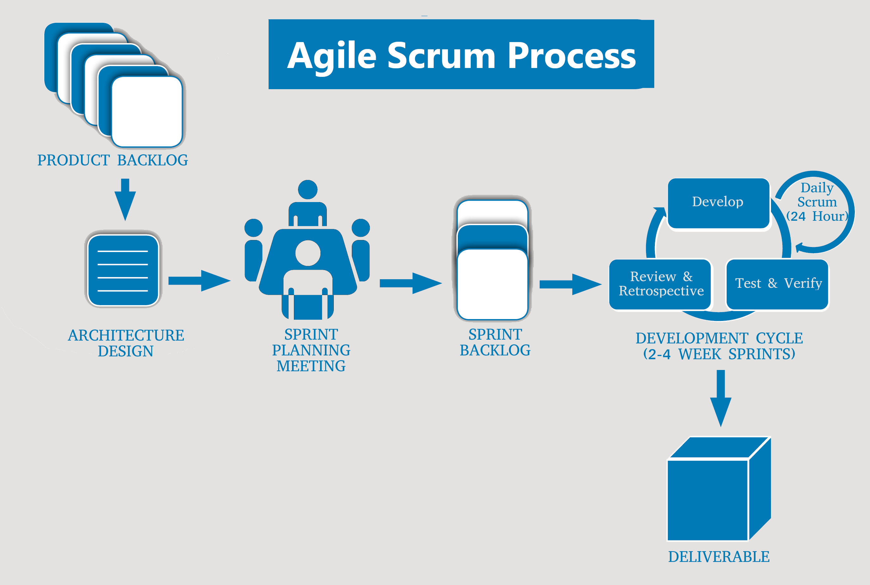

***Figure 1: Stages in Scrum***

**AGILE - SCRUM ORGANIZATION**

The SCRUM methodology involves the following three main players:

* Product owner: In most projects, the product owner is the leader of the client's project team. He is the one who will define and prioritize the product features and choose the date and content of each sprint based on values (workloads) that the team communicates to him.
* Scrum Master: He is a genuine facilitator on the project as he makes sure that everyone works at their full potential by eliminating impediments and protecting the team from exterior interferences. Moreover, he pays particular attention to the respect of the different SCRUM phases.
* Team: a team is typically made up of 4-10 people and groups together all the IT specialists who are necessary on a project, i.e. an architect, a designer, a developer, a tester etc. The team is self-organizing and remains unchanged during an entire sprint.

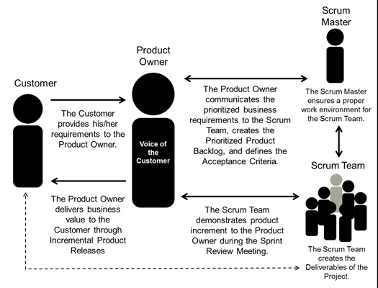

***Figure 2: Scrum team members***

**AGILE - SCRUM ADVANTAGES**

Scrum differs from other development methods through its advantages which turn it into a pragmatic response to product owners' current needs:

Iterative and incremental method: this allows avoiding the "tunnel effect", i.e. the fact of seeing the result only at the final delivery, and nothing or almost nothing during the entire development phase, which is so frequent with V-cycle developments.

Maximum adaptability for product and application development: the sequential composition of the sprint content allows adding a modification or a feature which was not initially planned. This is precisely what renders this method "agile".

* Participatory method: every team member is asked to express his opinions and can contribute to all the decisions taken on the project. He is therefore more involved and motivated.
* Enhancing communication: by working in the same development room or being connected through different communication means, the team can easily communicate and exchange opinions on the impediments in order to eliminate them as early as possible.
* Maximizing cooperation: daily communication between the client and the team enables them to collaborate more closely.
* Increasing productivity: as it removes certain "constraints" of the classical methods, such as documentation or exaggerated formalization, SCRUM allows increasing team productivity. By adding to this the qualification of each module which allows determining estimation, everyone can compare their performance to the average team productivity.

1. **Project’s Risk:**

***Table 7: Rating for likelihood and seriousness for each risk.***

|  |  |  |  |
| --- | --- | --- | --- |
| **Rating for Likelihood and Seriousness for each risk** | | | |
| **L** | Rated as Low | **E** | Rated as Extreme (Used for Seriousness only) |
| **M** | Rated as Medium | **NA** | Not Assessed |
| **H** | Rated as High |  |  |

***Table 8: Project Risk.***

|  |  |  |  |  |
| --- | --- | --- | --- | --- |
| **Risk** | **Definition** | **Level** | **Likelihood** | **Mitigation Strategy** |
| Estimates of project planning | The plan may be delayed for the initial estimate of the project. | L | L | Analysis and assessment of the scale.  Reduce requirements. |
| Requirements | Internal contradictions that may exist in the request.  Important requirements may be missing from the formal requirements specification. | H | H | Uniform requirements prior to analysis. |
| Estimated project schedule | Time sort of work. | M | M | Time project was created to be updated and evaluated regularly. |
| Programming experience | Programming Languages and technology | M | L | Experience sharing used to reduce the research time. |
| Technical processes | The standard procedure cannot meet the requirements of specific solutions.  The new process may be required.  The process can be improved and more efficient. | L | M | Analysis of requirements and processes to ensure appropriate levels.  If the new process is needed, we need to evaluate this response has improved over the old process. |
| Network | Block by Limited Bandwidth | H | H | Upgrade transmission line network |
| Time | Project implementation period is too short, so our team cannot complete this project on a short time.  During project implementation, our team to learn and have more work to do, our team cannot focus all their time to carry out this project. | H | M | Reduce time and increase individual personal time working in their stay on the 7th day and Sunday. |
| Project Management | Project management system may not be sufficient to support the requirements of the project. | L | H | Discuss with the group to offer solutions and consistent accuracy. |

1. **Deliverables:**

Table 9: Deliverables.

|  |  |  |  |
| --- | --- | --- | --- |
| **No.** | **Document** | **Deadline** | **File Name** |
| 1 | Proposal Document. | 05 –Sep– 2018 | E4UProposal v1.i.docx |
| 2 | Project Plan Document & Schedule Plan. | 27 –Sep– 2018 | E4UProject Plan v1.i.docx |
| 3 | Database Design Document. | 20 –Nov– 2018 | E4UDatabase Design v1.i.docx |
| 4 | Product Backlog Document. | 20 –Nov– 2018 | E4UProduct Backlog v1.i.docx |
| 5 | Sprint Backlog Document. | 24 –Nov– 2018 | E4USprint Backlog v1.i.xlsx |
| 6 | User Interface Document. | 20 –Nov– 2018 | E4UUser Interface v1.i.docx |
| 7 | Architecture Design Document. | 20 –Nov– 2018 | E4UArchitecture Design v1.i.docx |
| 8 | Test Plan Document. | 20 –Nov– 2018 | E4UTest Plan v1.i.docx |
| 9 | E-Examinations | 05 –Dec– 2018 | E4UCapstone.rar |
|  |  |  |  |